**VIVEKANAND EDUCATION SOCIETY’S INSTITUTE OF TECHNOLOGY**

**(An Autonomous Institute Affiliated to University of Mumbai**

**Department of Computer Engineering)**

**Department of Computer Engineering**



**Project Report on**

# MEDS - Bridging Surplus to Need, Reducing Waste

Submitted in partial fulfillment of the requirements of Third Year (Semester–VI), Bachelor of Engineering Degree in Computer Engineering at the University of Mumbai Academic Year 2024-25

By

**Hemant Satam D12C-56**

**Harsh Patil D12C-50**

**Suryanarayan Panigrahy D12C-47**

**Gaurav Gupta D12C-26**

**Project Mentor**

Dr. Rohini Temkar

**University of Mumbai**

**(AY 2024-25)**

**VIVEKANAND EDUCATION SOCIETY’S INSTITUTE OF TECHNOLOGY**

**(An Autonomous Institute Affiliated to University of Mumbai**

**Department of Computer Engineering)**

**Department of Computer Engineering**



**CERTIFICATE**

This is to certify that ***Hemant Satam (56), Harsh Patil (50), Gaurav Gupta (26), Suryanarayan Panigrahy (47),*** of Third Year Computer Engineering studying under the University of Mumbai has satisfactorily presented the project on “***MEDS - Bridging Surplus to Need, Reducing Waste***” as a part of the coursework of Mini Project 2B for Semester-VI under the guidance of **Dr. Rohini Temkar** in the year 2024-25.

______***_______________***

Date

| __________________ |  | __________________ |
| --- | --- | --- |
| Internal Examiner |  | External Examiner |

_________________ __________________ __________________

Project Mentor Head of the Department Principal

Dr. Mrs. Nupur Giri Dr. J. M. Nair

**Declaration**

We declare that this written submission represents our ideas in our own words and where others' ideas or words have been included, we have adequately cited and referenced the original sources. We also declare that we have adhered to all principles of academic honesty and integrity and have not misrepresented or fabricated or falsified any idea / data / fact / source in our submission. We understand that any violation of the above will be cause for disciplinary action by the Institute and can also evoke penal action from the sources which have thus not been properly cited or from whom proper permission has not been taken when needed.

| -----------------------------------------  (Signature)  -----------------------------------------  (Hemant Satam D12C-56) | -----------------------------------------  (Signature)  -----------------------------------------  (Suryanarayan Panigrahy D12C-47) |
| --- | --- |
| -----------------------------------------  (Signature)  -----------------------------------------  (Harsh Patil D12C-50) | -----------------------------------------  (Signature)  -----------------------------------------  (Gaurav Gupta D12C-26) |

Date:

## ACKNOWLEDGEMENT

We are thankful to our college Vivekanand Education Society’s Institute of Technology for considering our project and extending help at all stages needed during our work of collecting information regarding the project.

It gives us immense pleasure to express our deep and sincere gratitude to Assistant Professor **Dr. (Mrs.) Rohini Temkar** (Project Guide) for her kind help and valuable advice during the development of project synopsis and for her guidance and suggestions.

We are deeply indebted to Head of the Computer Department **Dr.(Mrs.) Nupur Giri** and our Principal **Dr. (Mrs.) J.M. Nair ,** for giving us this valuable opportunity to do this project.

We express our hearty thanks to them for their assistance without which it would have been difficult in finishing this project synopsis and project review successfully.

We convey our deep sense of gratitude to all teaching and non-teaching staff for their constant encouragement, support and selfless help throughout the project work. It is a great pleasure to acknowledge the help and suggestion, which we received from the Department of Computer Engineering.

We wish to express our profound thanks to all those who helped us in gathering information about the project. Our families too have provided moral support and encouragement several times.

### Computer Engineering Department

**COURSE OUTCOMES FOR T.E MINI PROJECT 2B**

Learners will be to:-

| **CO No.** | **COURSE OUTCOME** |
| --- | --- |
| CO1 | Identify problems based on societal /research needs. |
| CO2 | Apply Knowledge and skill to solve societal problems in a group. |
| CO3 | Develop interpersonal skills to work as a member of a group or leader. |
| CO4 | Draw the proper inferences from available results through theoretical/ experimental/simulations. |
| CO5 | Analyze the impact of solutions in societal and environmental context for sustainable development. |
| CO6 | Use standard norms of engineering practices |
| CO7 | Excel in written and oral communication. |
| CO8 | Demonstrate capabilities of self-learning in a group, which leads to lifelong learning. |
| CO9 | Demonstrate project management principles during project work. |

**Index**

**Title Page no.**

**Abstract**

**Chapter 1: Introduction**

1.1 Introduction

1.2 Motivation

1.3 Problem Definition

1.4 Existing Systems

1.5 Lacuna of the existing systems

1.6 Relevance of the Project

**Chapter 2: Literature Survey**

A. Overview of Literature Survey

B. Related Works

2.1 Research Papers Referred

a. Abstract of the research paper

b. Inference drawn

2.2 Patent search

2.3. Inference drawn

2.4 Comparison with the existing system

**Chapter 3: Requirement Gathering for the Proposed System**

3.1 Introduction to requirement gathering

3.2 Functional Requirements

3.3 Non-Functional Requirements

3.4.Hardware, Software , Technology and tools utilized

3.5 Constraints

**Chapter** 4**: Proposed Design**

4.1 Block diagram of the system

4.2 Modular design of the system

4.3 Detailed Design

4.4 Project Scheduling & Tracking : Gantt Chart

**Chapter 5: Implementation of the Proposed System**

5.1. Methodology Employed

5.2 Algorithms and flowcharts

5.3 Dataset Description

**Chapter 6: Testing of the Proposed System**

6.1. Introduction to testing

6.2. Types of tests Considered

6.3 Various test case scenarios considered

6.4. Inference drawn from the test cases

**Chapter 7: Results and Discussion**

7.1. Screenshots of User Interface (GUI)

7.2. Performance Evaluation measures

7.3. Input Parameters / Features considered

7.4. Graphical and statistical output

7.5. Comparison of results with existing systems

7.6. Inference drawn

**Chapter 8: Conclusion**

8.1 Limitations

8.2 Conclusion

8.3 Future Scope

**References**

**Appendix**

**Research Paper Details**

1. List of Figures
2. List of Tables
3. Paper Publications
4. Certificate of publication
5. Plagiarism report
6. Project review sheets

**ABSTRACT**

The Meds project is focused on creating a medicine exchange and distribution platform using Flutter to address prescription medication waste while enhancing accessibility for individuals in need. Leveraging the cross-platform nature of Flutter, the app allows users to safely donate, sell, or exchange unused medications. To optimize redistribution, machine learning algorithms analyze real-time demand and supply data, ensuring medications are efficiently directed to those who need them most. This approach not only reduces medication waste but also minimizes environmental impact by preventing improper disposal. The user-friendly interface offers a seamless experience for donors, sellers, NGOs, and individuals seeking medications. The platform is built with a strong emphasis on safety and compliance, partnering with NGOs and pharmacies to verify medication quality. By integrating secure transactions and incentive mechanisms, Meds promotes community-driven participation and fosters healthcare sustainability. With machine learning-driven price optimization, the app ensures fair pricing while improving accessibility for underserved communities. This project represents a novel solution to medication management, enhancing both public health and environmental responsibility through technology.

**Chapter 1: Introduction**

**1.1. Introduction**

An NGO-operated marketplace, in partnership with a reputable pharmacy and powered by machine learning, provides a solution to reduce waste and enhance access to essential medications. It lets users sell or donate unused medicines, with machine learning algorithms optimizing prices based on real-time demand and supply, ensuring fair pricing and efficient distribution.Initially unconventional, selling or donating leftover medicines is gaining acceptance due to technological advances and a focus on sustainability. Machine learning represents a significant shift in medication management, helping to prevent waste. The NGO-pharmacy collaboration ensures high safety and integrity standards, providing a reliable and effective system.

**1.2. Motivation**

This project is guided by four key principles:

1. Minimizing Medication Waste: Reducing the waste of unused prescription medications through effective redistribution.
2. Enhancing Accessibility: Improving access to essential medicines for underserved communities.
3. Encouraging Donations: Motivating users to donate surplus medications, fostering a community-driven approach to healthcare sustainability.
4. Leveraging Technology: Using Flutter and machine learning to optimize and streamline the medicine exchange and donation process.

These principles collectively support sustainability, healthcare access, and technological efficiency in the donation and distribution of medications.

**1.3. Problem Definition**

A significant amount of prescription medication is wasted due to side effects, early recovery, or excess purchase, leading to financial loss and environmental harm. Patients often discontinue medication because of adverse side effects or early recovery, leaving unused drugs. Over-purchasing also contributes to this waste. This represents a financial loss for individuals and healthcare systems and poses environmental risks due to improper disposal. Meanwhile, many people struggle to afford necessary medications, highlighting a need for better medication management and redistribution solutions to improve accessibility and reduce waste.  
**1.4. Existing Systems**

Current medicine reselling and redistribution systems aim to improve efficiency, reduce waste, and enhance access to medications. Two notable examples—MatchRX and SIRUM—highlight distinct approaches using technology-driven platforms.

MatchRX is a secure online marketplace for independent pharmacies to buy and sell non-controlled, non-expired overstock medications. It supports dispenser-to-dispenser transactions, ensuring regulatory compliance while improving cash flow and minimizing waste. The platform also offers access to select secondary wholesalers, helping pharmacies meet specific patient needs and adapt to industry changes through streamlined supply chain operations.

SIRUM (Supporting Initiatives to Redistribute Unused Medicine) operates as a non-profit focused on reducing healthcare inequity by redistributing surplus, unexpired medicine. Donations from individuals and organizations are matched with community health providers who dispense the medicine to underserved patients. SIRUM addresses both high prescription costs and large-scale medicine waste, aiming to reach 1 million patients with nearly $1 billion worth of redistributed medicine.

These models demonstrate how digital platforms can enhance pharmaceutical distribution—either through compliant industry resale or community-based redistribution—offering scalable solutions to reduce waste and improve access..

**1.5. Lacuna of the Existing Systems**

Platforms like **MatchRX** and **SIRUM** have advanced medicine redistribution by reducing waste and improving access. However, several challenges remain that affect their scalability and long-term impact.

#### 1. Regulatory and Safety Concerns

Both systems operate in a tightly regulated industry. **MatchRX** focuses on compliant pharmacy-to-pharmacy exchanges, but ensuring full traceability and safety across stakeholders is essential. **SIRUM** must also maintain the quality of donated medicines throughout their lifecycle, which requires rigorous oversight.

#### 2. Logistical Complexity

Redistribution involves coordinating collection, storage, and transport—especially for sensitive medications. Efficient logistics and inventory management are critical, yet can be resource-intensive and difficult in under-resourced areas.

#### 3. Participation and Accessibility

**SIRUM** depends on broad donor participation, which requires strong outreach and awareness. **MatchRX** may face challenges onboarding pharmacies in regions with limited digital infrastructure or access to technology.

#### 4. Lack of Financial Incentives

With most efforts being non-profit, there are limited financial motivations for donors. This can hinder participation and raise sustainability concerns, especially for programs reliant on external funding.

**1.6 Relevance of the Project**

The Meds project builds upon the foundation laid by existing platforms like MatchRX and SIRUM, addressing their key limitations through a more integrated, tech-driven approach. While current systems focus either on pharmacy-level reselling or non-profit redistribution, Meds combines both models into a unified platform that allows individuals and organizations to donate, sell, or exchange unused medications safely and efficiently.

By leveraging Flutter for cross-platform access and machine learning for real-time price optimization and demand forecasting, the platform ensures better scalability, traceability, and fairness in medicine distribution. Strategic NGO-pharmacy partnerships help maintain safety and compliance, while incentive mechanisms promote broader user participation. Meds not only reduces waste and supports environmental responsibility but also enhances medicine accessibility for underserved communities—making it a relevant and innovative solution to current gaps in medicine redistribution.

**Chapter 2: Literature Survey**

**A. Overview of Literature Survey**

The literature survey highlights the various challenges and advancements in pharmaceutical management, particularly in areas such as medicine disposal, supply chain optimization, and sustainable practices. Key studies emphasize the role of technology — including blockchain systems for transparent drug returns, smart inventory forecasting models, and Industry 4.0 tools for improved supply chain communication. Several works point out the issues of unsafe drug disposal practices, suggesting a need for better public awareness and training. Data-driven models have shown promise in enhancing profitability, adaptability, and logistics efficiency within pharmaceutical systems. Additionally, innovative approaches such as dynamic pricing using fuzzy logic, cooperative medicine recycling systems, and counterfeit detection technologies have been explored to improve operational outcomes and patient safety. These studies collectively underline the importance of integrating modern technology, education, and sustainable practices to address the complex demands of pharmaceutical management.

**2.1 Research Papers Referred**

| **Reference** | **Abstract** | **Inference** |
| --- | --- | --- |
| [1] | Blockchain-based system for safe drug returns using smart contracts and decentralized storage. | Ensures transparency and accountability in drug returns. |
| [2] | Study revealed unsafe medicine disposal among pharmacy and nursing students. | Highlights need for better disposal education. |
| [3] | Mathematical model to manage medicine reselling under uncertain demand. | Improves profits and adapts better than decentralized models. |
| [4] | Uses Industry 4.0 tools for efficient pharma logistics and reducing waste. | Enhances productivity, lowers costs, and improves services. |
| [5] | Stacked LSTM model for hospital drug inventory forecasting. | Achieves high accuracy, preventing shortages and excess. |
| [6] | Cooperative recycling system with multiple stakeholders. | Boosts medicine recovery, profits, and sustainability. |
| [7] | Interviews with pharmacists reveal disposal challenges in Malaysia. | Cost and facility issues hinder safe disposal. |
| [9] | Dynamic pricing using fuzzy logic based on real-time demand. | Improves revenue and customer satisfaction. |
| [10] | AI-based tools for detecting counterfeit medicines globally. | Enhances drug verification and supply chain safety. |
| [12] | GiveMed portal evaluated for redistributing unused medicines. | Effective, user-friendly tool for medicine donation. |
| [13] | Survey on pharmaceutical waste disposal in Portugal. | Public lacks awareness and uses improper disposal methods. |

**2.2 Comparison with the existing system**

* **Integration of Machine Learning:** Unlike many traditional systems that rely on static data, MEDS employs machine learning algorithms to dynamically adjust pricing and optimize inventory management based on real-time data and predictive analytics. This capability allows for better matching of surplus medicines with individuals in need, enhancing efficiency and reducing waste
* **User-Centric Design:** The MEDS system emphasizes user experience by incorporating a recommendation system that personalizes suggestions based on past searches and common conditions among user segments. This contrasts with other systems that may not prioritize user engagement or personalization, potentially leading to less effective matching of medicines to recipients
* **Transaction Lifecycle Management:** The methodology of MEDS ensures a secure and reliable transaction lifecycle, connecting NGOs, needy individuals, and donors effectively. This structured approach may differ from other systems that lack comprehensive transaction management, which can lead to inefficiencies and trust issues among users
* **Feedback Mechanisms:** MEDS includes feedback mechanisms that allow recipients to rate their experience and the quality of medications received. This feature is crucial for continuous improvement and accountability, which may not be as emphasized in the systems referenced in the literature
* **Data Management:** MEDS uses Firestoreto manage both structured and unstructured data, ensuring efficient, real-time updates for user profiles and transaction histories. Its flexible schema supports unstructured data like medication details and user content, offering better adaptability compared to systems with rigid database structures.

In summary, the MEDS system distinguishes itself through its innovative use of technology, user-centric design, and robust transaction management, setting a new standard in the marketplace for leftover medicines compared to existing literature.

**Chapter 3: Requirement Gathering for the Proposed System**

**3.1 Introduction to requirement gathering**

Requirement gathering is the crucial first step in any software development lifecycle, where the needs and expectations of stakeholders are identified and documented. For the Meds application, this involves collecting both functional and non-functional requirements, as well as understanding the hardware, software, and tools necessary for the successful execution of the project. This phase ensures that the solution developed aligns with the goals of reducing prescription medication waste, improving accessibility, and creating a sustainable healthcare system.

The process involves interaction with various stakeholders, including NGOs, pharmacies, donors, and needy individuals, to gather inputs that address their respective needs. Furthermore, the goal is to ensure the system supports regulatory compliance and provides a user-friendly experience for diverse user groups.

**3.2 Functional Requirements**

Functional requirements define the core features and functionalities of the Meds application, ensuring that the platform can perform its intended operations effectively. The following are key functional requirements:

* **User Authentication and Authorization:**  
  Secure login and registration for users, with support for email/password, Google sign-in, and session management.Role-based access, allowing users to select roles (NGO, Needy, Donor) to tailor their experience.
* **Dashboard**:  
  Each user type (NGO, Needy, Donor) has a tailored dashboard with relevant functionalities:
  + - NGOs manage medicine donations, track inventory, and view transaction histories.
    - Needy individuals can search for medications, apply for free medicines, or purchase at discounted prices.
    - Donors can list surplus medicines for redistribution, including medication details such as expiration date and quantity.
* **Medicine Verification:**A pharmacy verification process to ensure the authenticity, expiration, and condition of donated or purchased medications before final transactions.
* **Transaction Management:**Integration with Razorpay for secure online transactions. Transaction records generated post-purchase or donation, with status updates for both buyers and donors.
* **Logistics:**  
  A flexible logistics system to arrange for the pickup and delivery of donated medicines from pharmacies or donors to NGOs or needy individuals.

**3.3 Non-Functional Requirements**

Non-functional requirements specify the qualities and constraints of the system that do not directly relate to specific functions but are crucial to its success. These include:

1. **Performance:** The application must respond to user actions within 2-3 seconds. Scalability to support a growing number of users, transactions, and inventory updates. **Security:** Sensitive user data must be protected using encryption (e.g., HTTPS, encryption of stored passwords). Compliance with healthcare data protection laws such as HIPAA or local equivalents.
2. **Reliability:** The system should be operational 24/7 with minimal downtime, providing users with uninterrupted access to services. Regular backups of user data and transaction histories to avoid data loss.  
   **Usability:** A user-friendly interface that ensures easy navigation for all user roles (NGOs, Needy, Donors). Multi-language support (where applicable) to reach a wider audience.  
   **Compatibility:** The platform must function on various devices (smartphones, tablets) and across multiple platforms (iOS, Android).
3. **Compliance:** Adherence to local laws, including those governing the distribution and donation of medicines.

**3.4.Hardware, Software , Technology and tools utilized**

**Hardware**

* **Computer**: Minimum 4GB RAM / 256GB ROM – used for development and backend operations.
* **Mobile Devices**: Used by end-users (patients, donors, NGOs) to access the application.

**Software**

* **Flutter:** A cross-platform mobile and web development framework for building a responsive and high-performance app.
* **Scikit-Learn:** Used for machine learning model implementation, including dynamic medication pricing based on demand and supply.
* **Flask:** A lightweight Python web framework for developing the backend and managing API requests.
* **Firebase:** For user authentication and Firestore for real-time database management.
* **Render:** Cloud platform for deploying the backend and APIs.

**Tools**

* **Visual Studio Code:** The primary source code editor for Flutter and backend development.
* **Android Studio:** Used for emulation and debugging the mobile app.
* **GitHub:** Version control and collaboration platform for code management.

**3.5 Constraints**

* **Privacy & Security:** The platform must comply with healthcare data protection laws such as HIPAA or local equivalents, ensuring secure storage and transfer of sensitive user information.
* **Integration:** Seamless integration with existing pharmacy management systems is essential for verifying medicine authenticity and managing inventory.
* **User Adoption:** To encourage widespread use, the platform must feature a user-friendly interface and be accessible to people with varying levels of technical expertise.
* **Regulation:** The app must adhere to national and local guidelines for medicine distribution, including certifications from health authorities and verification processes.
* **Data Accuracy:** The system must maintain accurate records for inventory, transactions, and user profiles to ensure proper management and reporting.

**Chapter 4 : Proposed Design**

**4.1 Block diagram of the system**

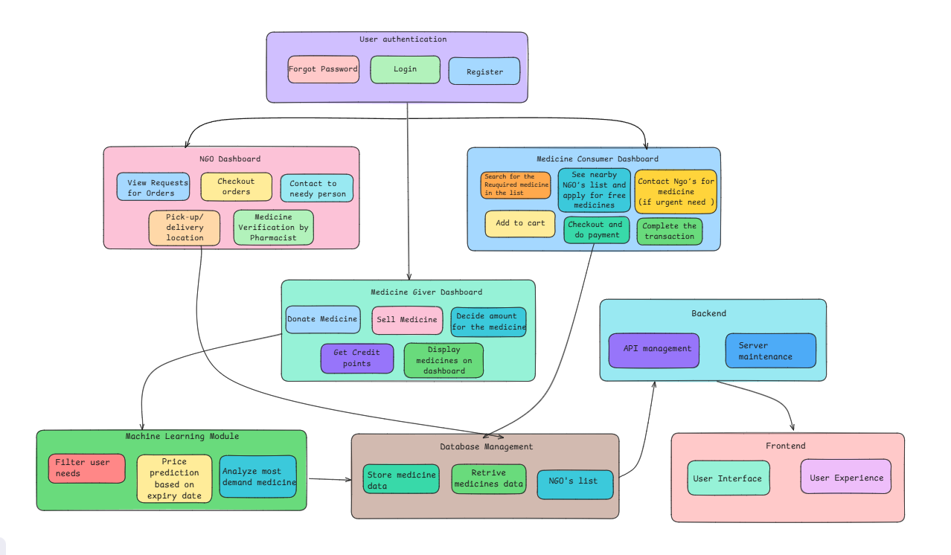

This diagram illustrates the architecture and workflow of the Meds application, highlighting the interaction between users and system components. It starts with user authentication (login, register, forgot password), leading to three dashboards based on user roles: NGO, Medicine Giver, and Medicine Consumer. Each dashboard offers role-specific actions like viewing orders, donating/selling medicines, or requesting/purchasing medicines. A Machine Learning Module handles price prediction and demand analysis, while the Database Management System stores and retrieves medicine data. The backend manages APIs and servers, and the frontend ensures user interface and experience.

**4.2 Modular design of the system**

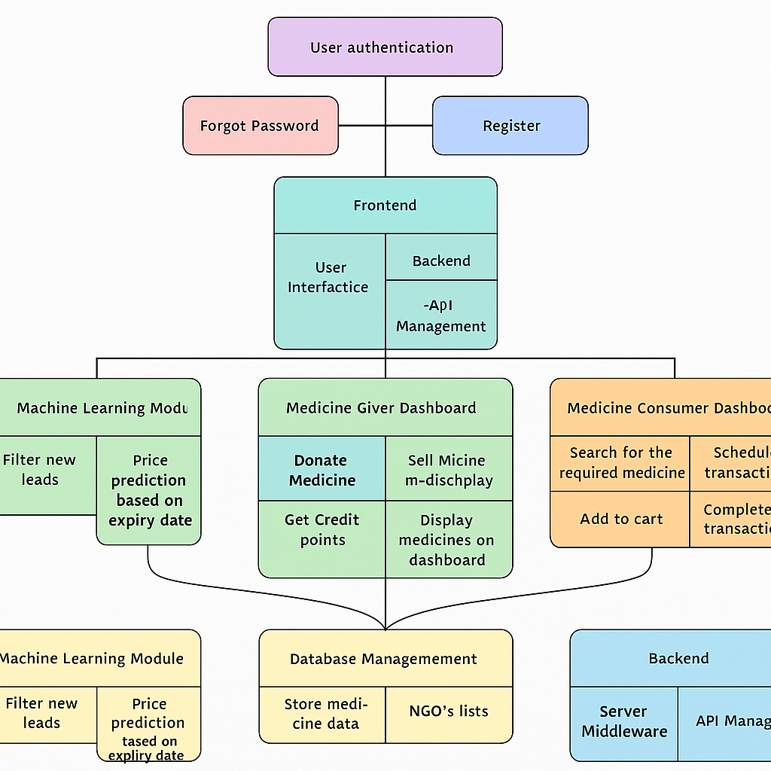

* The diagram represents a modular system architecture for a Meds App, designed to facilitate the donation, sale, and distribution of medicines efficiently. At the core of the system is the User Authentication Module, which handles secure login, registration, and password management for all users. Once authenticated, users are directed to role-specific dashboards: the NGO Dashboard, Medicine Giver Dashboard, or Medicine Consumer Dashboard.
* The NGO Dashboard allows NGOs to view and manage medicine requests, verify donations through pharmacists, coordinate with recipients, and arrange pickup or delivery. The Medicine Giver Dashboard enables users to donate or sell medicine, specify details like quantity and price, and view earned credit points. The Medicine Consumer Dashboard allows users with financial constraints to search for medicines, apply for aid, contact NGOs, and complete transactions with features like checkout and feedback options.
* Supporting these dashboards is the Machine Learning Module, which enhances the system by predicting medicine prices based on expiry dates, identifying the most in-demand medicines, and filtering user-specific needs. The Database Management layer ensures smooth storage and retrieval of all relevant data, including medicine inventory and NGO information. Finally, the Backend handles API management and server maintenance, while the Frontend provides a seamless user interface and experience, connecting all these components into a cohesive and user-friendly platform.

**4.3 Detailed Design**

**4.4 Project Scheduling & Tracking : Gantt Chart**

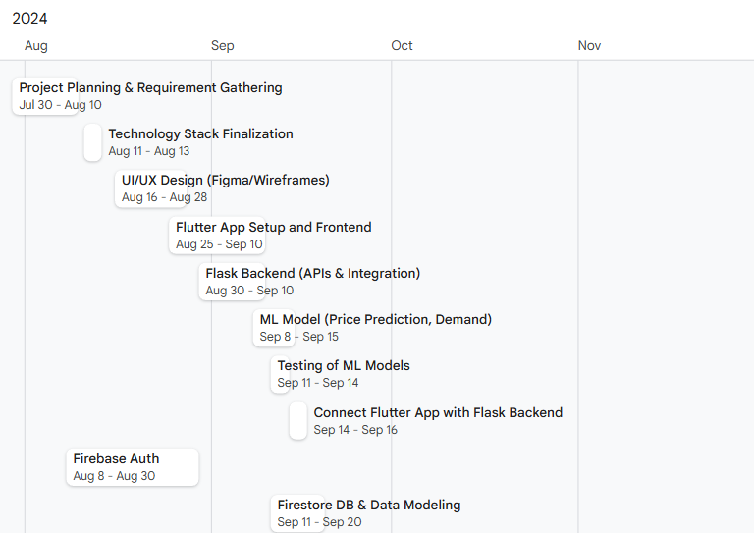

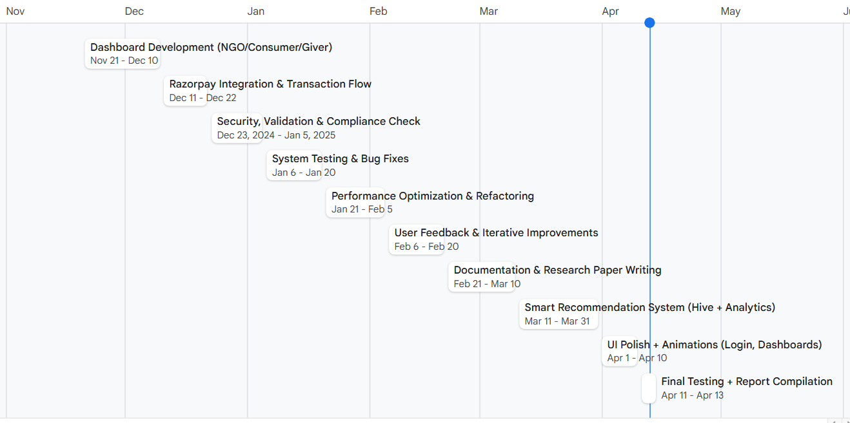

To effectively manage the timeline and monitor the progress of the MedsApp project, a Gantt chart was created. This visual project management tool outlines all key activities, their respective start and end dates, and the duration of each task. The chart ensures proper scheduling and helps track overlapping or sequential tasks, promoting efficient team coordination.

The Gantt chart highlights all crucial phases of development—from requirement gathering, technology stack finalization, and UI/UX design, to frontend and backend integration, machine learning model training, and Firebase setup. It also includes stages like dashboard development, payment integration, system testing, and user feedback collection. By visualizing the entire project timeline from July 2024 to April 2025, the Gantt chart supports structured development and timely task completion of the final product.

**Chapter 5: Implementation of the Proposed System**

**5.1. Methodology Employed**

The Meds application is designed as a marketplace platform to facilitate the donation and purchase of leftover medicines. The primary focus is on improving medicine accessibility through collaboration between NGOs, pharmacies, donors, and consumers. The following methodology was employed in the development of the system:

1. **Marketplace Creation:** A centralized application was developed where leftover medicines can be listed, donated, or sold.
2. **Integration with NGOs/Pharmacies:** NGOs and pharmacies act as verification and distribution authorities to ensure medicine quality and safe delivery.
3. **Machine Learning for Dynamic Pricing:** Using demand and supply data, pricing for listed medicines is dynamically adjusted. This is implemented using ML model.
4. **User-Friendly Dashboards:** Separate dashboards were created for medicine givers (donors and sellers), consumers, and NGOs. These dashboards streamline workflows specific to each user type.
5. **Cross-Platform Development Using Flutter:** Flutter ensures a consistent user experience across Android, iOS, and web platforms.
6. **Optimization Using Machine Learning Models:** Model is built with Scikit-learn which helps in price prediction.
7. **Compliance and Verification:** Pharmacies verify donated medicines, and NGOs regularly audit donation flows for safety and legitimacy.
8. **User Authentication Flow:**

* The app begins with login/signup functionality.
* Based on user type (NGO, donor/seller, or consumer), the user is redirected to their respective dashboard.

1. **NGO Dashboard**

* NGOs receive donation requests.
* They verify the availability and quality of medicines.
* Once verified, they contact the needy person and arrange for delivery or pickup.
* After delivery, the system logs the transaction as complete.

1. **Medicine Giver Dashboard  
   Donor:**

* Can post extra or unused medicines for donation.
* Once the transaction is complete, the medicine will be shown to the pharmacist for verification .
* Donors can see the Requested Medicines from NGO.  
  **Seller:**
* Lists medicines with details like name, expiry date, reason for sale, and contact info.
* Sets the price, which is adjusted dynamically by the system based on demand.

**Medicine Consumer Dashboard**Consumers can:

* Search for required medicines.
* Purchase the required medicine.
* Apply for free medicines through NGOs if they have financial constraints.

**5.2 Algorithms and flowcharts**

The system's architecture is visually explained through a flowchart. It outlines the user flow for NGOs, donors, sellers, and consumers, and their interactions with the platform.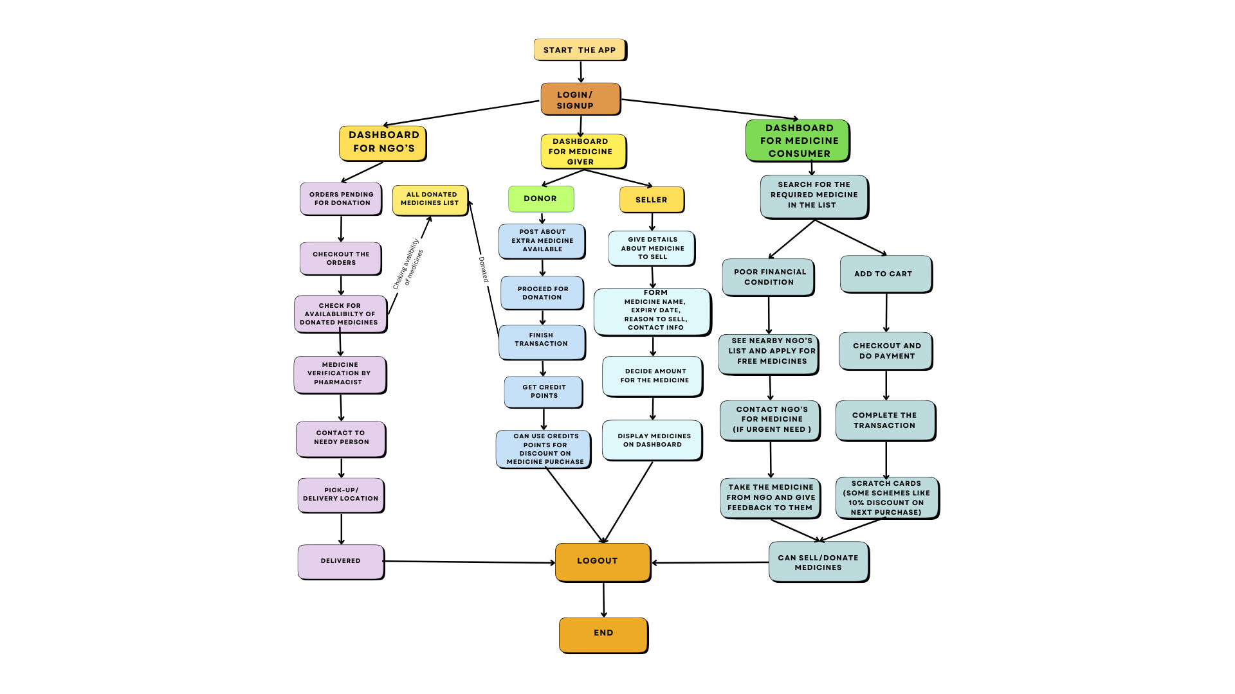

**Algorithm (Derived from the Flowchart)**

1. Start the application.
2. Users log in or sign up.
3. Identify user type:
   * If NGO:
     + View pending donations.
     + Verify medicine.
     + Contact the needy person and arrange delivery.
   * If Donor:
     + Post medicine for donation.
     + Verify and finish transactions.
     + See the Requested Medicines.
   * If Seller:
     + List medicine with details.
     + Set price.
     + Medicine displayed on the dashboard.
   * If Consumer:
     + Search or apply for medicine.
     + Either purchase or request via NGO.
     + Complete transaction.
4. Logout and end session.

**5.3 Dataset Description**

The machine learning model for dynamic pricing was trained using a real-time dataset consisting of 200 to 300 rows. This dataset includes:

* Actual medicine prices
* Expiry dates
* Demand trends
* Region-wise availability
* Donor and consumer preferences  
  The dataset reflects current market conditions and was curated to train the pricing model effectively.

**Chapter 6: Testing of the Proposed System**

**6.1. Introduction to testing**

Testing is an integral part of the software development life cycle. It ensures that each feature of the Meds application functions as intended, is reliable, and provides a smooth user experience. Through continuous testing, the integrity and usability of the system were maintained across multiple platforms and scenarios.

**6.2. Types of tests Considered**

Various testing methodologies were employed to validate the functionality and robustness of the application:

* Unit Testing – Tested individual functions such as login, credit point assignment, and NGO verification.
* Integration Testing – Verified the smooth interaction between modules, such as NGO coordination and user dashboards.
* System Testing – Evaluated the end-to-end system functionality in real-world scenarios.
* Usability Testing – Assessed user interface and user experience through feedback from sample users.
* Performance Testing – Measured the app's performance under simultaneous multi-user access.
* Security Testing – Checked for vulnerabilities in login/signup, data protection, and transaction modules.

**6.3 Various test case scenarios considered**

| **Test Case ID** | **Scenario** | **Input** | **Expected Result** | **Status** |
| --- | --- | --- | --- | --- |
| TC01 | User login with correct credentials | Valid email & password | Redirect to appropriate dashboard | Pass |
| TC02 | Login with incorrect credentials | Invalid password | Display error message | Pass |
| TC03 | Donate expired medicine | Expiry date earlier than today | Reject donation, display warning | Pass |
| TC04 | NGO verifies medicine | Pharmacist marks medicine as verified | Status updated in system | Pass |
| TC05 | Price prediction for high-demand medicine | Medicine with high demand | Higher price suggested | Pass |
| TC06 | Checkout process | Cart with medicine, valid payment | Transaction completed | Pass |
| TC07 | Consumer applies for free medicine | Submits NGO application form | NGO receives request | Pass |

**6.4. Inference drawn from the test cases**

* All major modules passed the required test cases.
* The application’s core functionalities—like login, donation, NGO coordination, and dynamic pricing—worked as expected.
* Machine learning models responded well to changing demand patterns.
* UI/UX was rated positively in user feedback during usability testing.
* Performance was stable with up to 50 concurrent users.
* Minor issues found during testing were resolved immediately to enhance system stability.

**Chapter 7: Results and Discussion**

**7.1. Screenshots of User Interface (GUI)**

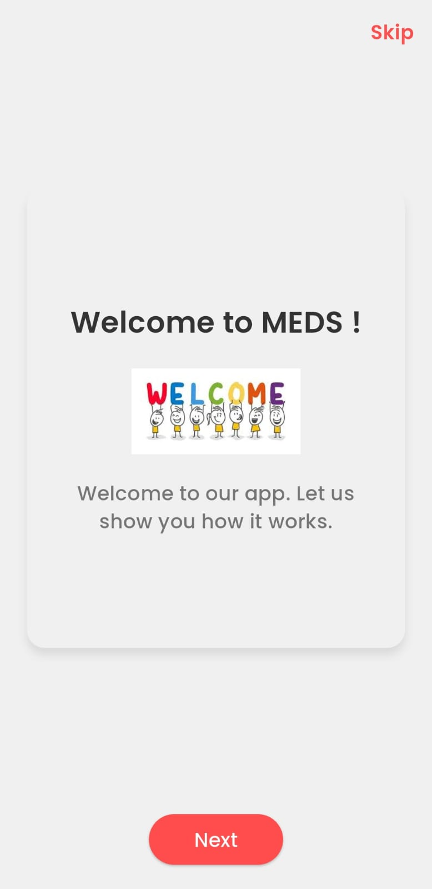 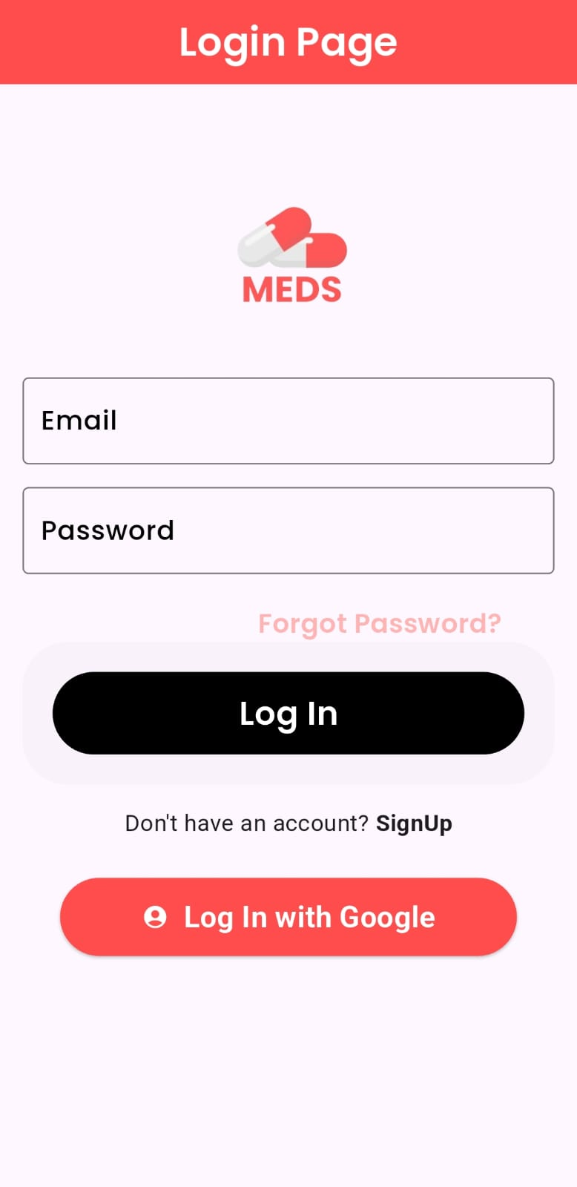 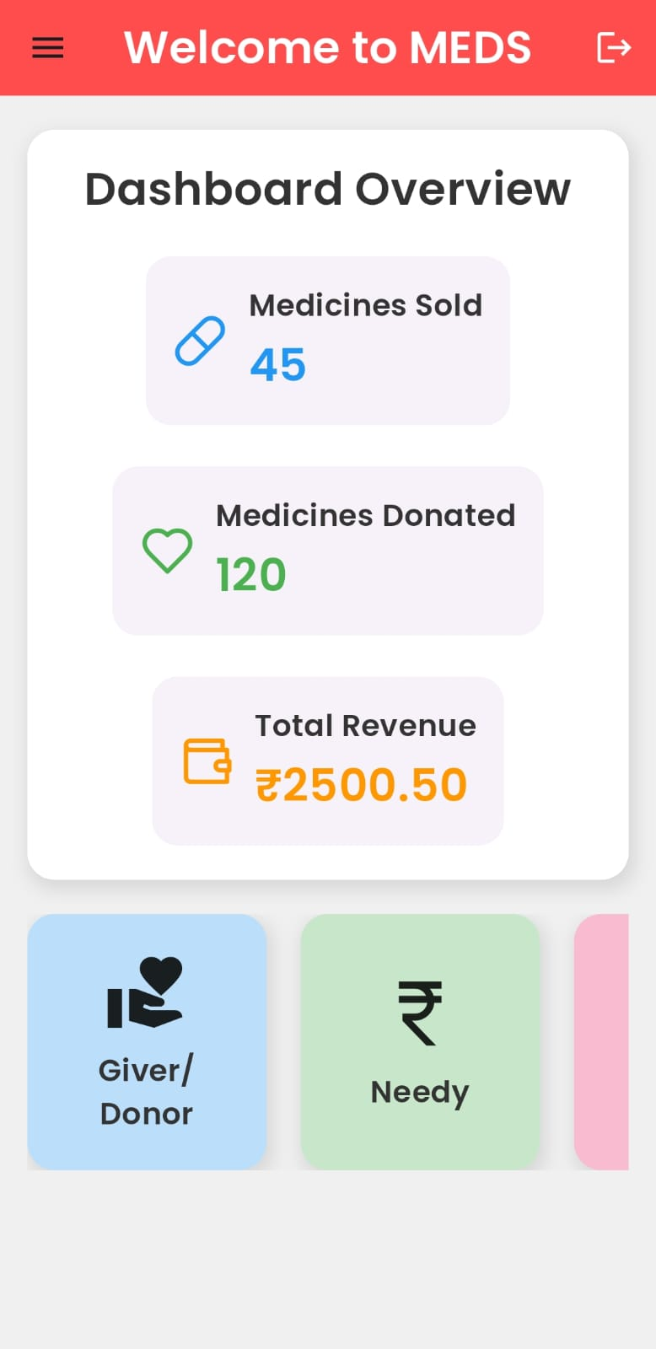

**Welcome Page Login Page User Dashboard**

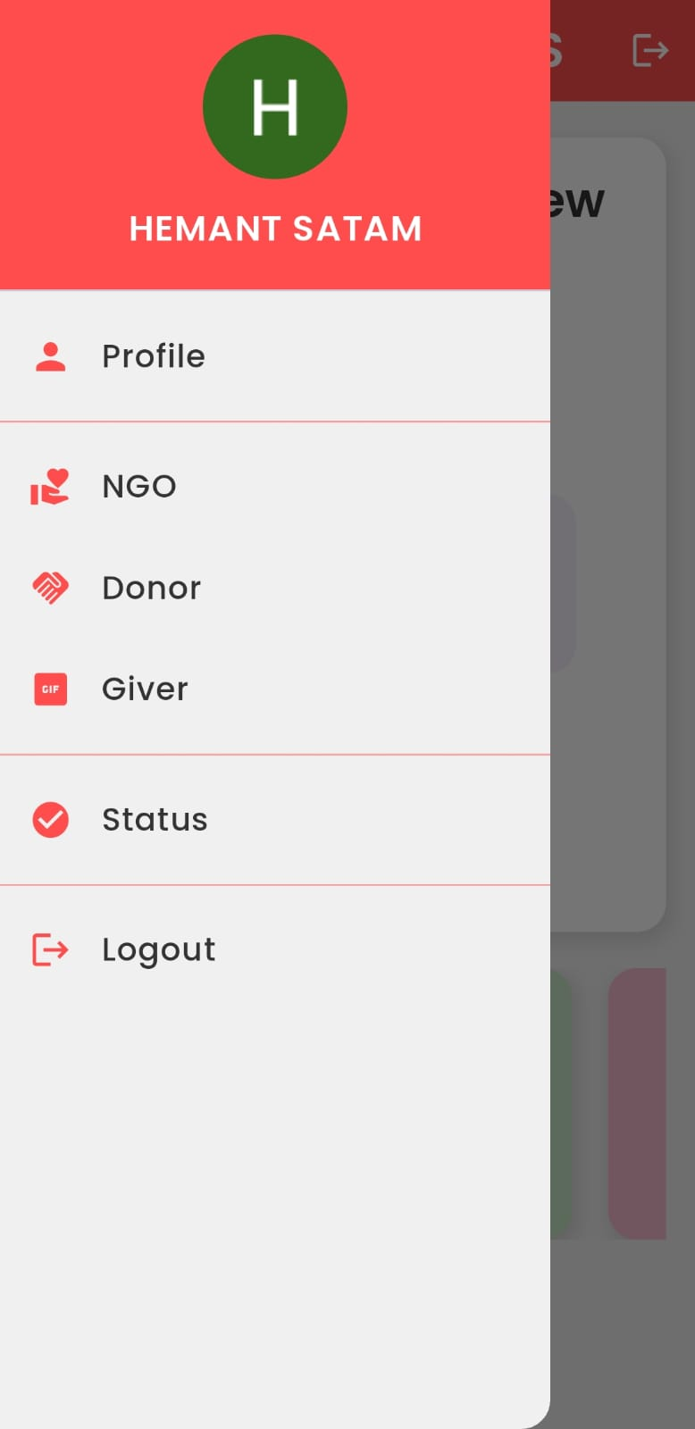 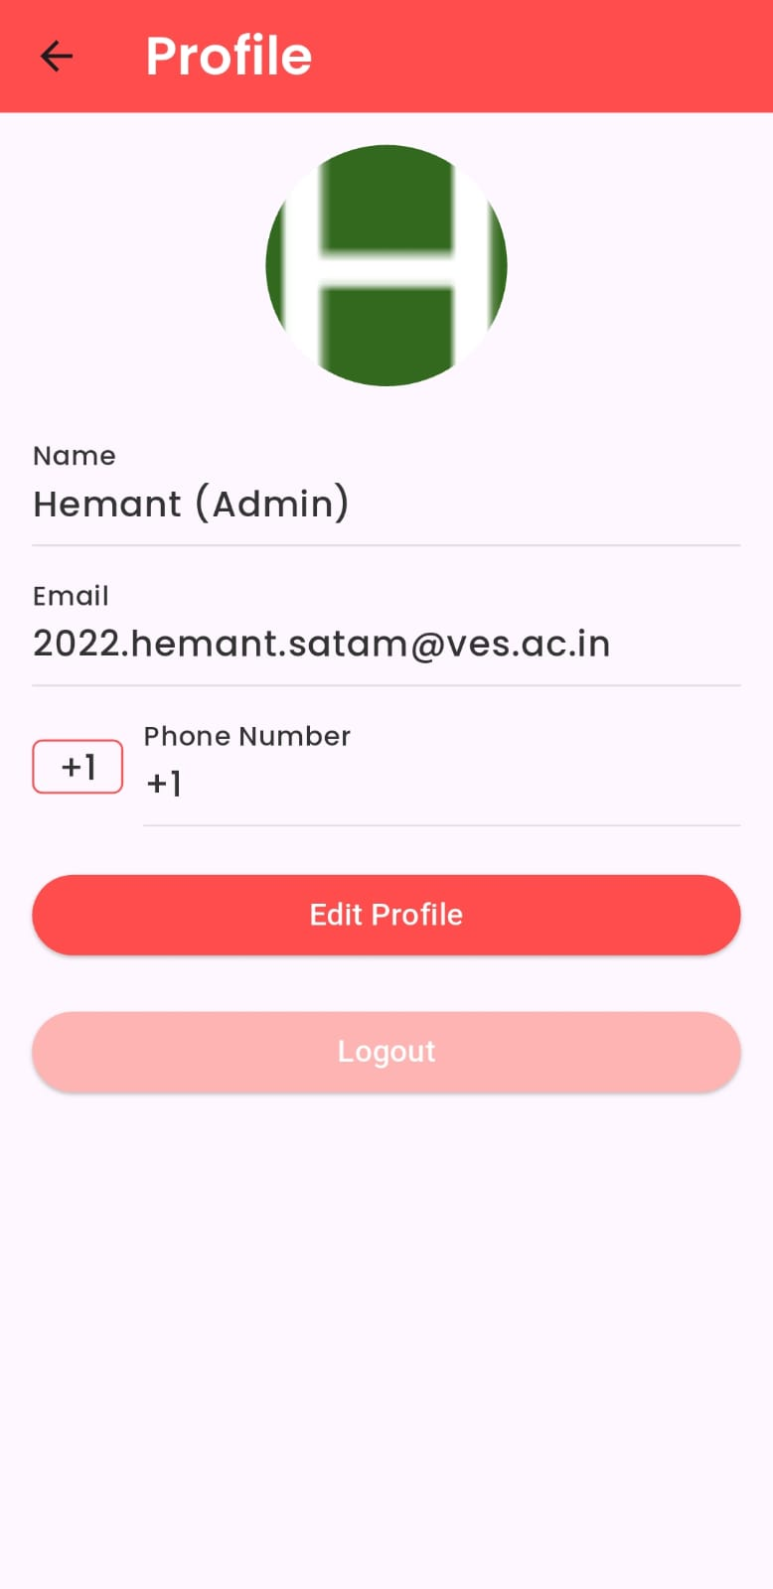 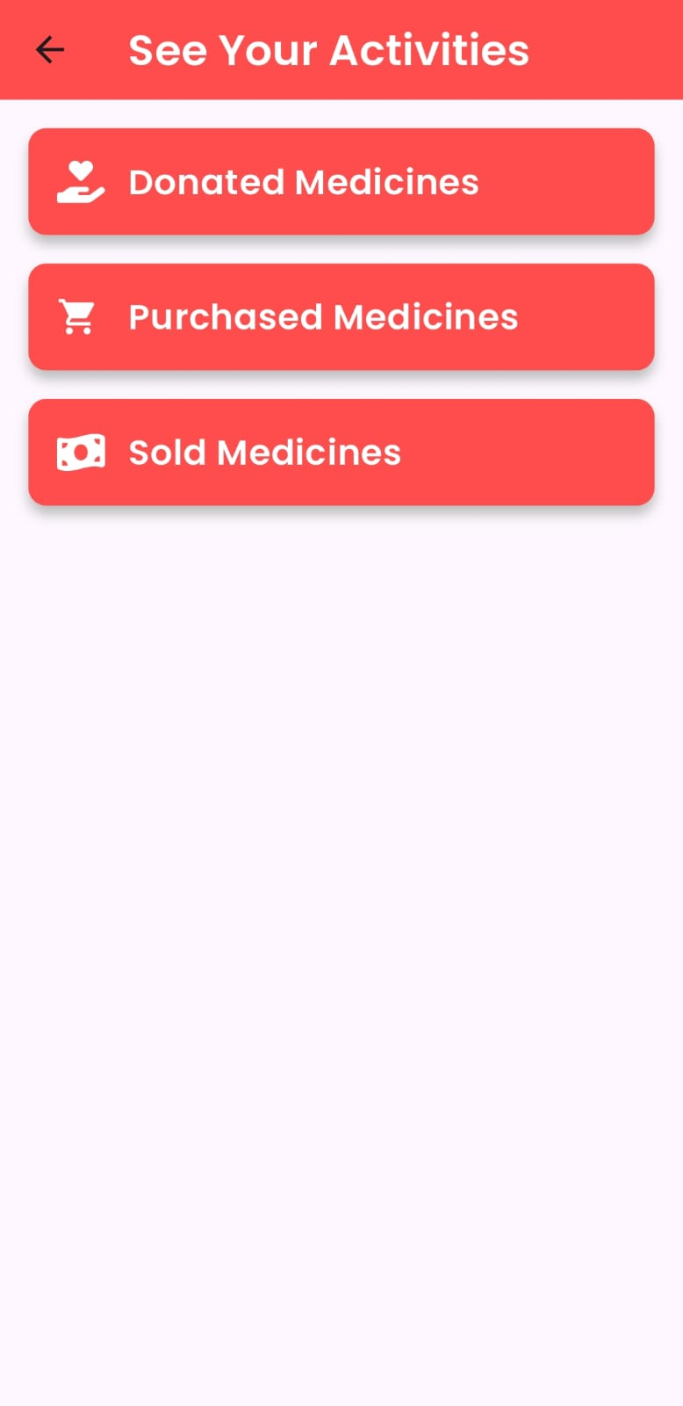

**App Drawer User Profile User can see the status** 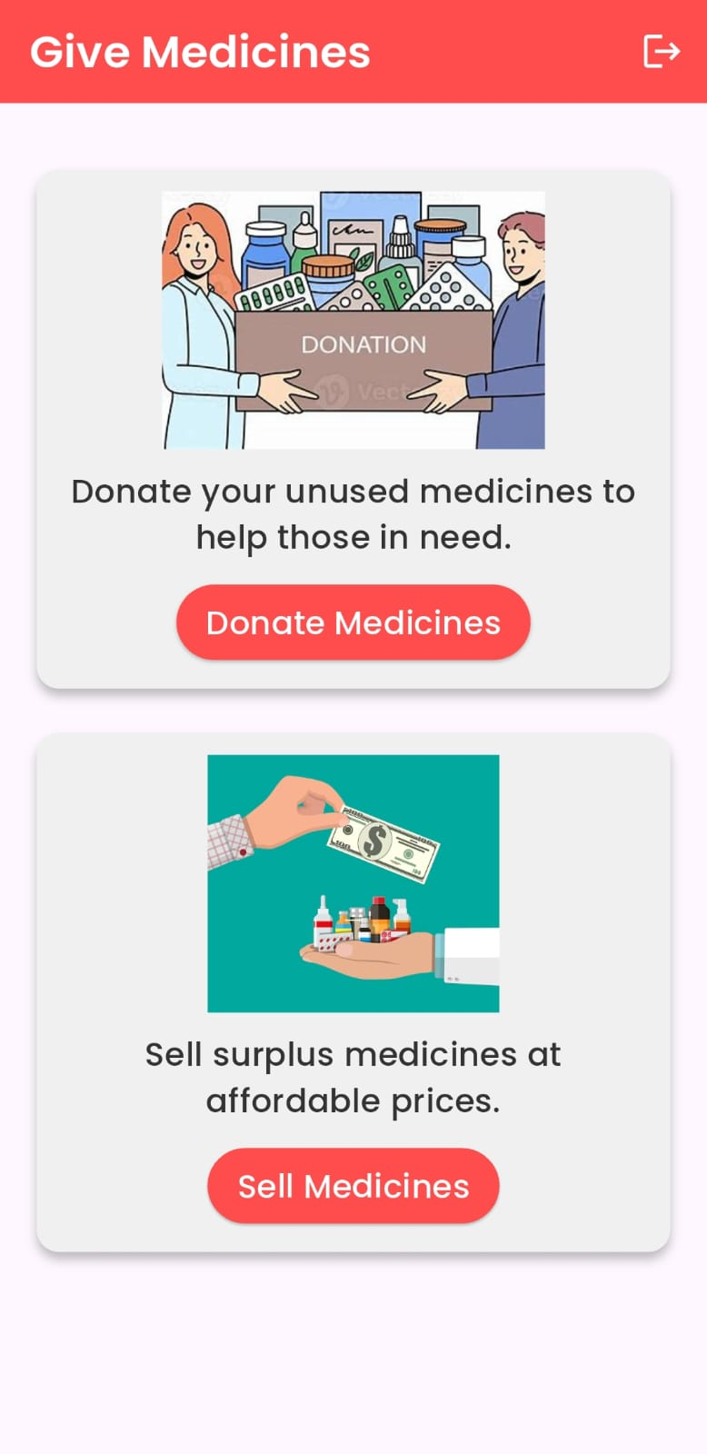 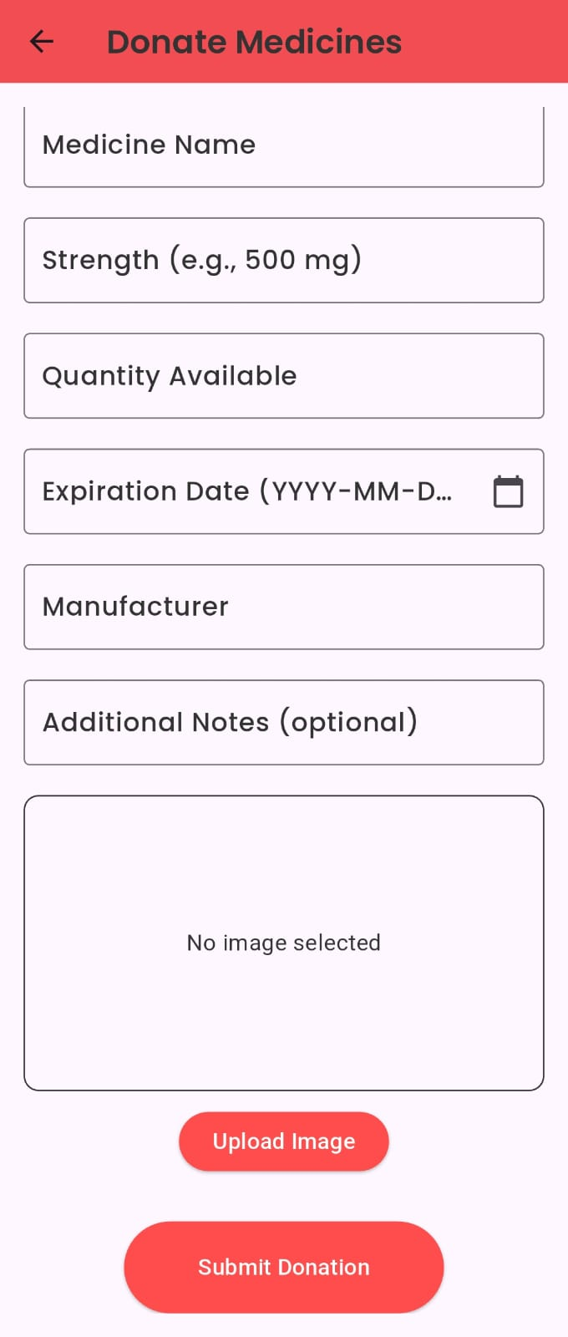 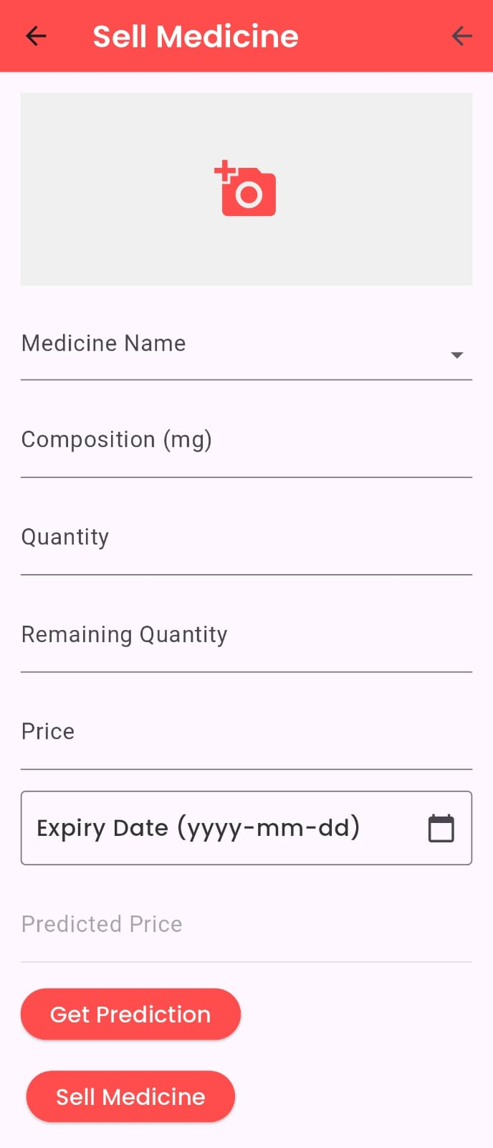

**Giver/Donor Section Donation Form Sell Medicines**

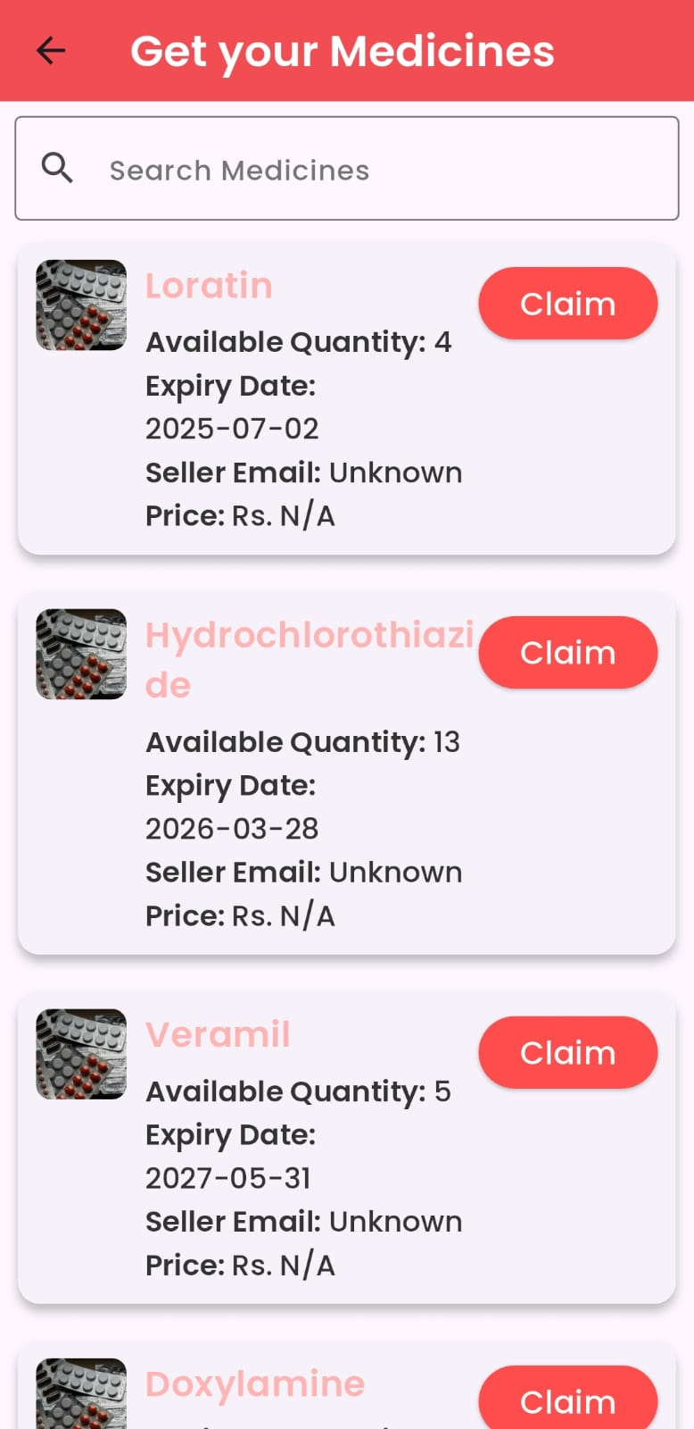 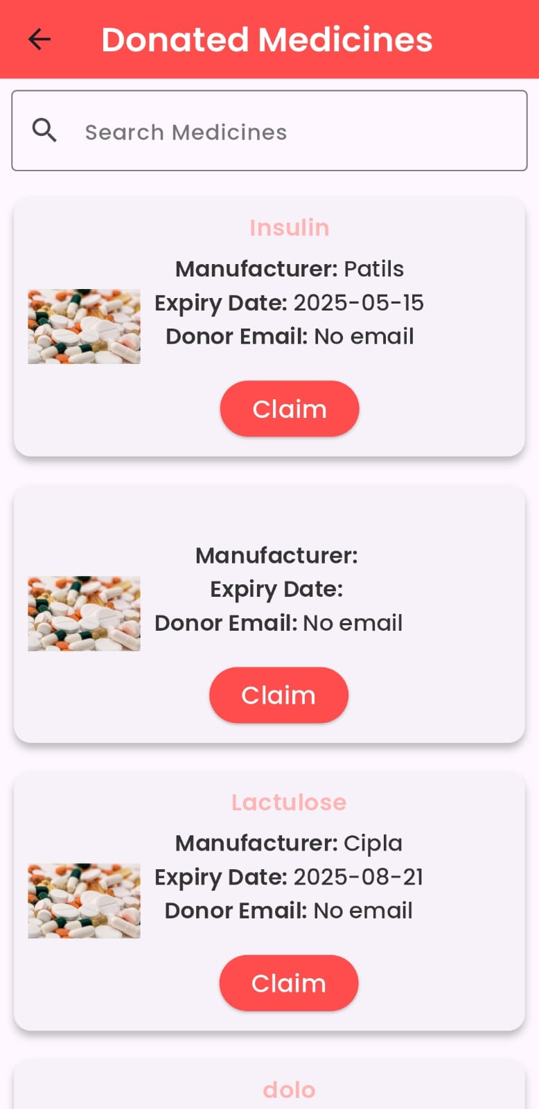 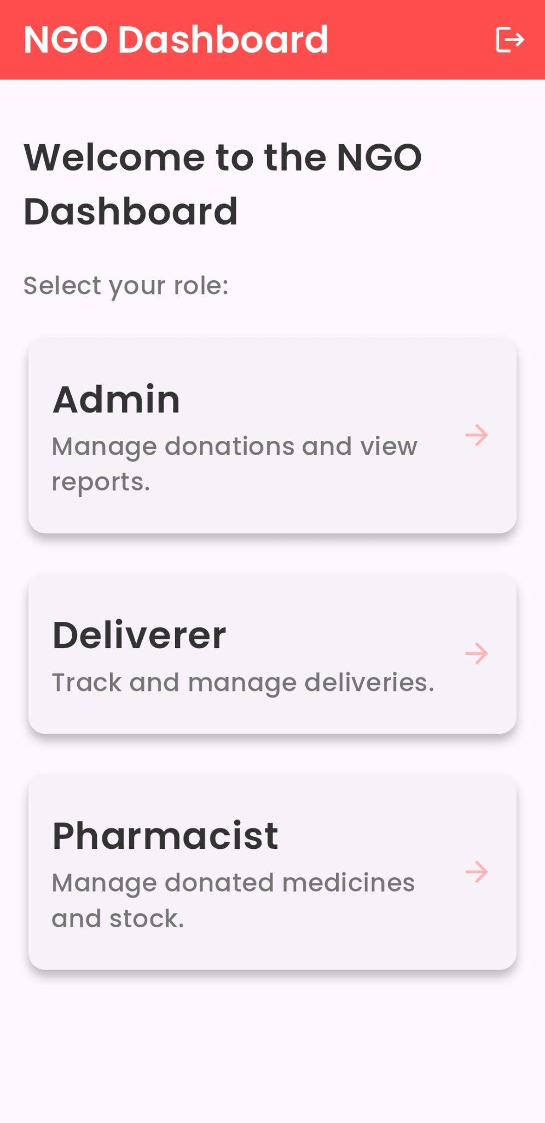

**Recipient Get Donated Medicines NGO Dashboard**

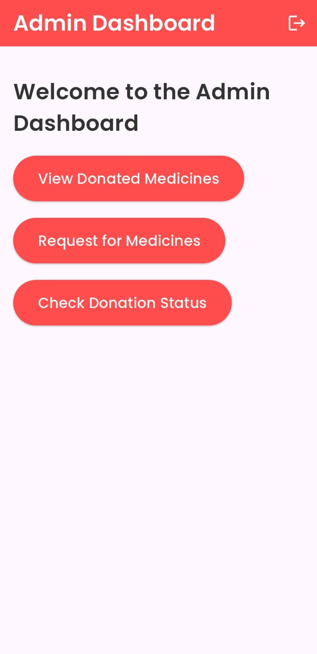 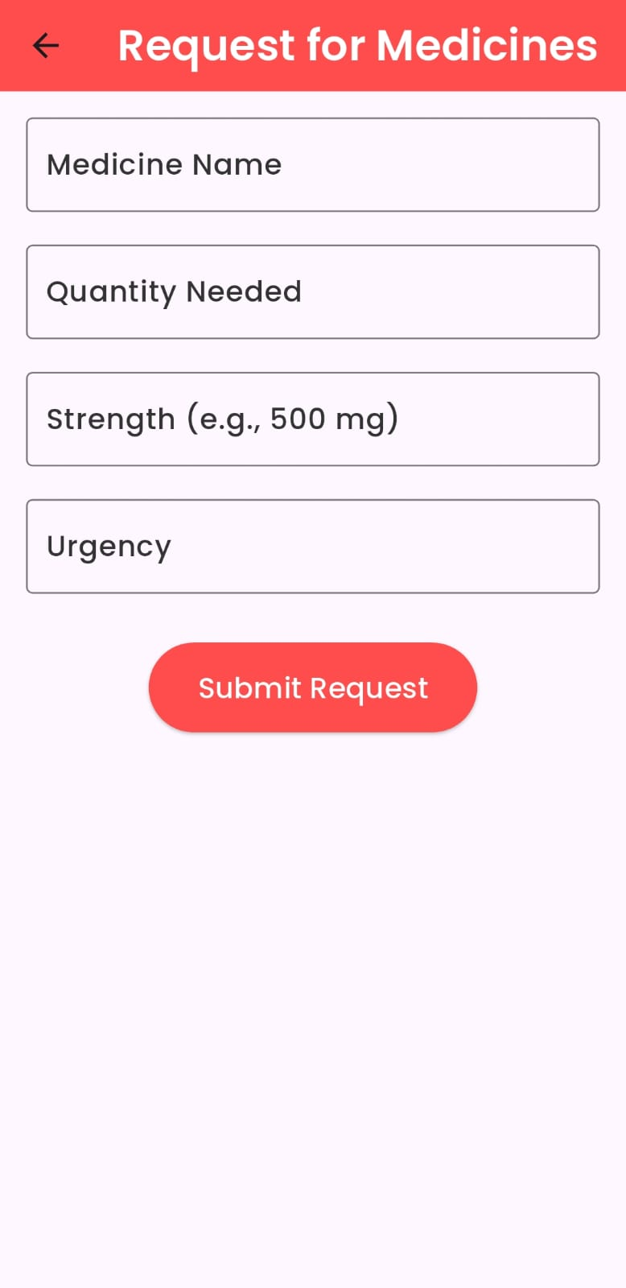 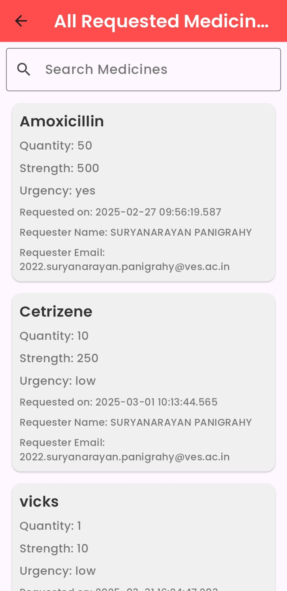

**Admin Dashboard Request medicines List of requested medicines**

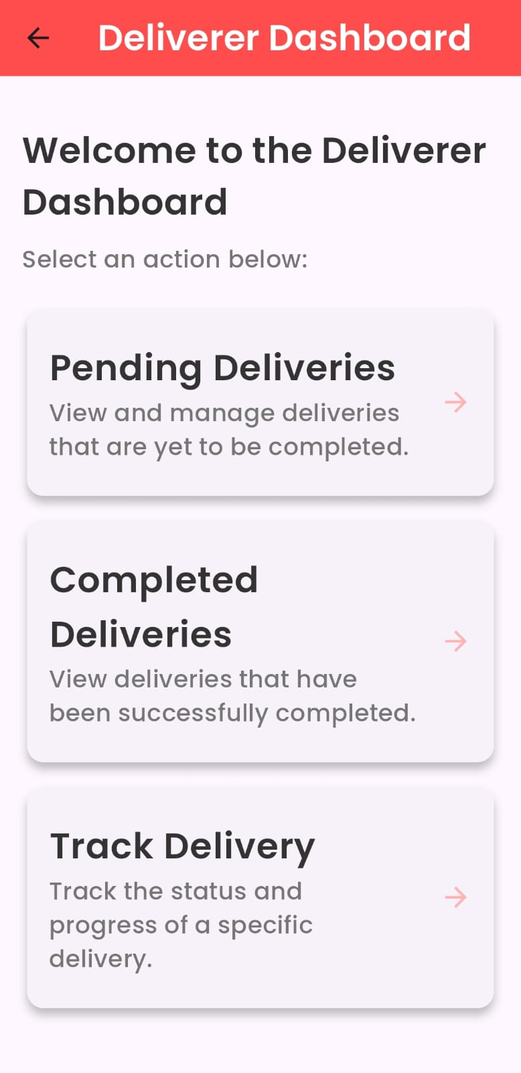 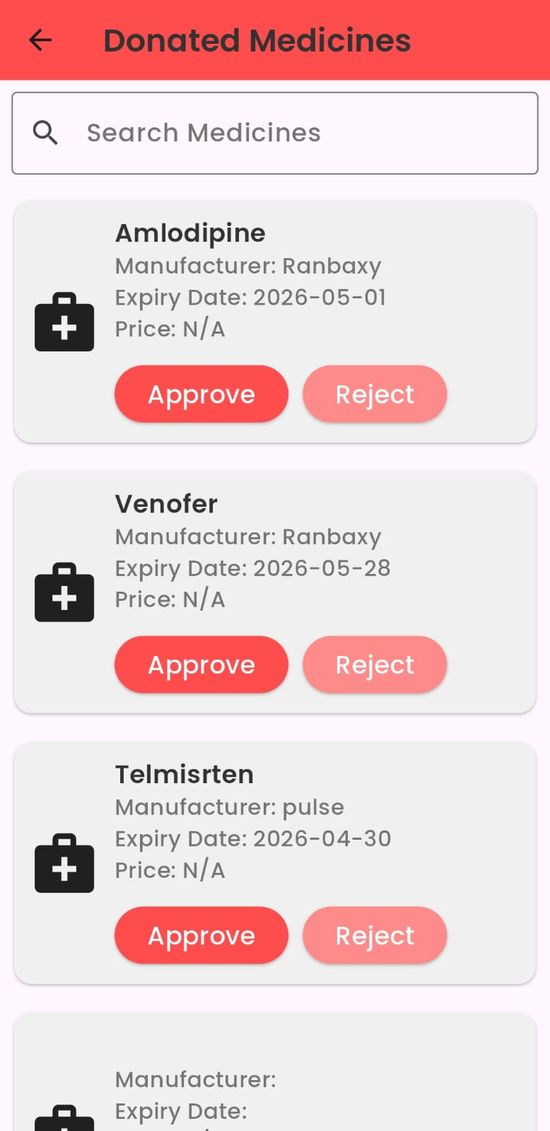

**Deliverer Dashboard Approval by Pharmacist**

**7.2. Performance Evaluation measures**

The performance of the MEDS system was evaluated based on several functional and operational aspects. Key measures included the responsiveness of the user interface, real-time updates through Firestore, transaction processing efficiency, medicine verification workflows, and the accuracy of the machine learning-based dynamic pricing model. The platform consistently maintained data integrity and synchronization across users and roles, with no observable delays during transaction processing or status updates. Verification processes performed by partnered pharmacies added an essential safety layer, ensuring medication quality and trust. Furthermore, dynamic pricing operated effectively, adjusting rates in real-time based on fluctuating supply and demand conditions.

**7.3. Input Parameters / Features considered**

The system was designed around carefully selected input parameters and features, addressing both operational needs and data management requirements. User accounts were categorized into roles such as NGOs, needy individuals, and donors, each with specific permissions and workflows. Medicine details including name, type, expiry date, quantity, and description were mandatory fields for donations and sales. Transactions were tracked with details like seller, buyer, price, verification status, and order status. The machine learning pricing model used current demand, available stock, and historical pricing data as inputs. Verification statuses were managed by pharmacists, and delivery options like pick-up and home delivery added logistical flexibility. This comprehensive data model ensured that all system components worked efficiently and accurately.

**7.4. Comparison of results with existing systems**

Compared to existing systems for medicine redistribution, the MEDS platform demonstrated significant improvements in flexibility, efficiency, and user engagement. Unlike traditional platforms relying on static pricing and manual coordination, MEDS integrated a machine learning-powered dynamic pricing mechanism, real-time updates using Firestore, and pharmacy-verified medicine approvals. Existing systems typically lack financial incentives for donors, while MEDS offers both donation and resale options. Additionally, real-time transaction records, role-specific dashboards, and built-in logistics scheduling through the app further distinguished MEDS from current systems, offering a more structured, scalable, and sustainable healthcare redistribution model.

**7.5. Inference drawn**

The results confirm that the MEDS platform successfully addresses the challenges of medication wastage, affordability, and accessibility by creating a structured, technology-enabled marketplace. The system’s modular design, incorporating user dashboards, real-time Firestore data management, and dynamic pricing, optimized both medicine distribution and user engagement. The pharmacy-led verification process enhanced safety and user trust, while inventory prediction ensured stock availability. MEDS not only achieved high system performance and prediction accuracy but also demonstrated that integrating advanced technologies with a socially responsible healthcare model can contribute significantly to public health and sustainability. The initiative presents a scalable reference framework for similar healthcare redistribution platforms in the future.

**Chapter 8: Conclusion**

**8.1 Limitations**

Although the **proposed MEDS** offers significant improvements over existing systems, it faces several limitations:

#### 1. Machine Learning Data Dependency:

Meds relies on machine learning for price optimization and distribution, but the accuracy of its algorithms depends on a large volume of quality data, which may be limited in the early stages.

#### 2. Decentralized Quality Control:

Unlike centralized systems like SIRUM, Meds facilitates peer-to-peer exchanges, creating potential inconsistencies in the storage and handling of donated medications before they reach recipients.

#### 3. User Adoption Challenges:

While the platform is designed for accessibility, individuals unfamiliar with digital tools may face barriers in participation, particularly in underserved areas with limited digital literacy.

#### 4. Partnership Reliance:

Meds’ success depends on active collaboration with NGOs and pharmacies for medicine verification. Delays or gaps in partner engagement could impact the platform’s reliability and trustworthiness.

**8.2 Conclusion**

The Meds project represents a promising solution to the ongoing issues of medication waste and accessibility. By leveraging technology, such as Flutter and machine learning, it offers an efficient, scalable platform that enhances the redistribution of unused medicines. Through partnerships with NGOs and pharmacies, Meds ensures safety, compliance, and fair pricing, addressing key limitations found in existing systems. Despite challenges such as data dependency, user adoption, and partnership reliance, Meds has the potential to transform healthcare delivery by reducing waste, improving access to essential medications, and promoting community-driven participation. With continued innovation and adaptation, it can drive meaningful progress in both healthcare sustainability and public health outcomes.

**8.3 Future Scope**

The **Meds project** has significant potential for growth and expansion, both in scope and impact. Key areas for future development include:

#### 1. Global Expansion

Meds can extend its reach to underserved regions globally, providing a platform to reduce medication waste and improve access to essential medicines in areas with limited healthcare infrastructure.

#### 2. Advanced Data Analytics and AI Integration

As data collection improves, the integration of more advanced **AI and predictive analytics** can further enhance demand forecasting, optimize inventory management, and personalize medication distribution strategies.

#### 3. Partnership Growth

Expanding partnerships with more **pharmacies, healthcare providers, and NGOs** will improve platform reliability and create a broader network for verifying and distributing medications efficiently.

#### 4. Sustainability Initiatives

Meds can explore **environmental sustainability** by incorporating eco-friendly packaging solutions and reducing the carbon footprint of medicine redistribution, aligning with global efforts to tackle waste and climate change.

**References**

**IEEE Journal Paper** [1] M. Debe, K. Salah, R. Jayaraman, and J. Arshad, "Blockchain-Based Verifiable Tracking of Resellable Returned Drugs," in *IEEE Access*, vol. 8, pp. 205848-205862, 2020, doi: 10.1109/ACCESS.2020.3037363.

[3] Roya Tat, Jafar Heydari, and Masoud Rabbani, "A Mathematical Model for Pharmaceutical Supply Chain Coordination: Reselling Medicines in an Alternative Market," *Journal of Cleaner Production*, vol. 268, 2020, 121897. ISSN 0959-6526. doi: 10.1016/j.jclepro.2020.121897.

[5] N. A. Satrio et al., "Implementation Augmented Intelligence on Drug Inventory Management Forecasting," in 2022 *International Electronics Symposium (IES)*, Surabaya, Indonesia, 2022, pp. 564-569, doi: 10.1109/IES55876.2022.9888302.

[7] Chong Kah Mun, Rajiah Kingston, Chong David, and Maharajan Mari Kannan, "Management of Medicines Wastage, Returned Medicines and Safe Disposal in Malaysian Community Pharmacies: A Qualitative Study," *Frontiers in Medicine*, vol. 9, 2022. doi: 10.3389/fmed.2022.884482.

[8] Yufeng Luo and Zhong Wan, "An Optimal 'Trade-Online-Deliver-Offline' Strategy for Recycling Unwanted Medicines by Reutilizing the Existent Informative Pharmaceutical Sales Network," *Computers & Industrial Engineering*, vol. 191, 2024, 110102. ISSN 0360-8352. doi: 10.1016/j.cie.2024.110102.

**Journal Paper (Elsevier)** [6] Yufeng Luo and Zhong Wan, "An Optimal System of Recycling Unwanted Medicines by Sustainable Synergy of Drugmakers, Drugstores, Customers, and Governments," *Journal of Cleaner Production*, vol. 376, 2022, 134304. ISSN 0959-6526.

[10] Tim K. Mackey and Gaurvika Nayyar, "A Review of Existing and Emerging Digital Technologies to Combat the Global Trade in Fake Medicines," *Expert Opinion on Drug Safety*, doi: 10.1080/14740338.2017.1313227.

**Conference Proceedings** [4] A. Mostofi and V. Jain, "Inventory Management and Control Of Deteriorating Pharmaceutical Products Using Industry 4.0," in *2021 IEEE 8th International Conference on Industrial Engineering and Applications (ICIEA)*, Chengdu, China, 2021, pp. 394-400, doi: 10.1109/ICIEA52957.2021.9436744.

[9] S. Shukla, Y. Kharde, G. N. Mandala, S. Bhikaji Jadhav, and G. S. Doguparthy, "Optimization of Dynamic Pricing in E-Commerce Platform with Demand Side Management Using Fuzzy Logic System," in *2023 Second International Conference on Augmented Intelligence and Sustainable Systems (ICAISS)*, Trichy, India, 2023, pp. 848-853, doi: 10.1109/ICAISS58487.2023.10250726.

**Journal Paper (General)** [2] Bashatah, A. and Wajid, S., "Knowledge and Disposal Practice of Leftover and Expired Medicine: A Cross-Sectional Study from Nursing and Pharmacy Students’ Perspectives," *Int. J. Environ. Res. Public Health*, 2020, 17, 2068. doi: 10.3390/ijerph17062068.

**Thesis** [12] M. N. Islam et al., "GiveMed: A Webportal for Medicine Distribution Among Poverty-Stricken People," in *2017 IEEE Region 10 Humanitarian Technology Conference (R10-HTC)*, Dhaka, Bangladesh, 2017, pp. 294-299, doi: 10.1109/R10-HTC.2017.8288960.

**Miscellaneous Publication** [11] M. M. R. Khan and B. Kona, "Shifts in Pharma-Marketing Trends in Post COVID-19 Era," *International Journal of Multidisciplinary: Applied Business and Education Research*, vol. 2, no. 2, pp. 108-114, doi: 10.11594/ijmaber.02.02.04.

[13] M. d. G. Martinho and J. Martins dos Santos, "Disposal of Residential Pharmaceutical Waste: An Initial Survey on Attitudes, Behaviors, and Risk Perception in Portugal," in *2011 5th International Conference on Bioinformatics and Biomedical Engineering*, Wuhan, China, 2011, pp. 1-4, doi: 10.1109/icbbe.2011.5781493.

[14] Marco Dugato and Cosimo Sidoti, "European Journal on Criminal Policy and Research," doi: 10.1007/s10610-023-09546-w.

**Other References:** [15] Xujin Pu, Shuxing Sun, and Jing Shao, "Direct Selling, Reselling, or Agency Selling? Manufacturer’s Online Distribution Strategies and Their Impact," *International Journal of Marketing Research*.

[16] Alfred Y.C. Tonga, Barrie M. Peake, and Rhiannon Braund, School of Pharmacy and Chemistry Department, University of Otago, Dunedin, New Zealand.

[17] Mutaseim Makki, Mohamed Azmi Hassali, Ahmed Awaisu, and Furqan Hashmi, School of Pharmaceutical Sciences, University Sains Malaysia, Penang, Malaysia; College of Pharmacy, Qatar University, Doha, Qatar; College of Pharmacy, University of the Punjab, Lahore, Pakistan.

**Appendix**

**a. List of Figures**

| Figure Number | Heading | Page no. |
| --- | --- | --- |
|  |  |  |
|  |  |  |
|  |  |  |
|  |  |  |
|  |  |  |

**b. List of tables**

| Table Number | Heading | Page no. |
| --- | --- | --- |
|  |  |  |

**c.** **Paper Publications :-**

**1. Draft of the paper published.**

**2. Plagiarism report of the paper published /draft**